** Office of the Chief**

Chief John R. Batiste

www.wsp.wa.gov

Captain Neil Weaver

**\*\*\* For Immediate Release \*\*\***

Government and Media Relations

**Date: June15, 2021**

**Contact:** Trooper Rick Johnson

**Email:** Rick.Johnson@wsp.wa.gov

**Phone:** (425) 766-0812

**Twitter:** @wspd2pio

**Rock Throwing Crime Causes Collision Sending Driver To Hospital**

**King County:** At approximately 11:14 PM on June 14, 2021 Washington State Patrol (WSP) communications received a 9-1-1 call advising of a one car collision EB 90 near Rainier Ave.

Once troopers arrived they were able to determine that the collision was caused by a rock being thrown through the windshield striking the driver in the face as he was traveling in the eastbound lanes. The vehicle then struck the barrier on the left side of the freeway. The driver was temporarily unconscious, unable to remember the collision and transported to Harborview due to a serious facial laceration.

It was determined that the rock was thrown from the construction site in between the east and westbound lanes of I-90 and no suspect was located in the area.

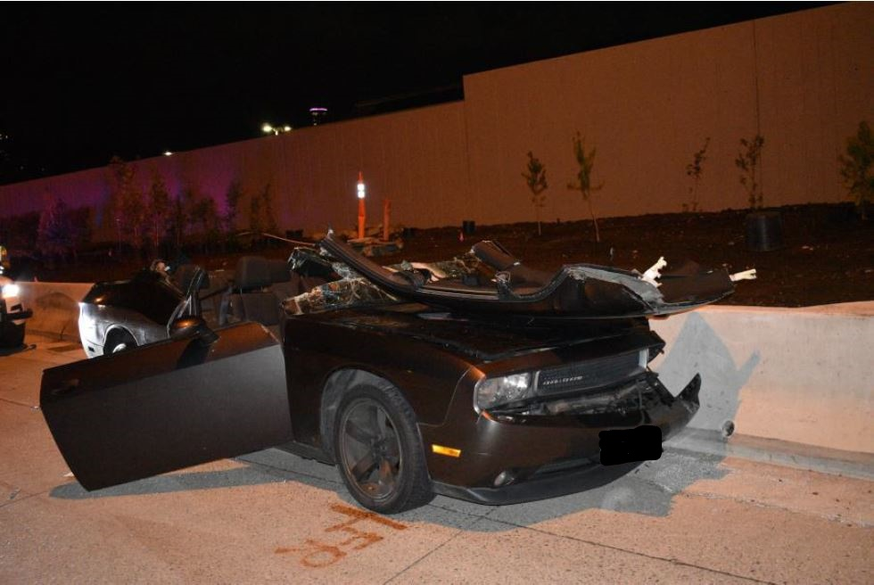

The Washington State Patrol (WSP) is working jointly with the Seattle Police Department (SPD) and Washington State Department of Transportation (WSDOT) to locate and arrest the suspect(s) that are committing this dangerous crime. Year to date there have been 74 reported rock throwing incidents in the downtown Seattle I-5 and I-90 corridor.

Below are the actions that are being taken to assist in locating and arresting the suspect(s).

* **Using analysts to establish a pattern of date, time and location in order to deploy troopers/officers to the area during this timeframe.**
* **Increasing the number of troopers in the area as much as possible.**
* **Using WSP aircraft in the area to assist in locating the suspect(s) when the rock throwing occurs.**
* **Coordinating with WSDOT to have their camera turned to the areas where this most commonly occurs.**

The efforts listed above are ongoing however it is difficult due to the fact that the location and time vary. These criminal actions being made by unidentified subject(s) are intolerable and all efforts are being made to quickly apprehend the suspect to protect public safety. .

It is imperative that our citizens traveling in the downtown Seattle area call 9-1-1 if any pedestrians are observed whether they are throwing rocks or not. Provide a description, location and action that is occurring as accurately as possible.

This is a dangerous crime that can result in charges ranging from a misdemeanor to a felony.

This is a high priority occurrence and efforts will continue until we locate and arrest those that are responsilble!

.

**###**